**ASSIGNMENT 2 FRONT SHEET**

|  |  |  |  |
| --- | --- | --- | --- |
| **Qualification** | **BTEC Level 5 HND Diploma in Computing** | | |
| **Unit number and title** | Unit 1: Programming | | |
| **Submission date** |  | **Date Received 1st submission** |  |
| **Re-submission Date** |  | **Date Received 2nd submission** |  |
| **Student Name** | Nguyễn Nguyên Vũ | **Student ID** |  |
| **Class** |  | **Assessor name** | Nguyễn Tuấn Đăng |
| **Student declaration**  I certify that the assignment submission is entirely my own work and I fully understand the consequences of plagiarism. I understand that making a false declaration is a form of malpractice. | | | |
|  |  | **Student’s signature** |  |

**Grading grid**

|  |  |  |  |  |  |  |  |  |  |
| --- | --- | --- | --- | --- | --- | --- | --- | --- | --- |
| P2 | P3 | P4 | P5 | M2 | M3 | M4 | D2 | D3 | D4 |
|  |  |  |  |  |  |  |  |  |  |

|  |  |  |
| --- | --- | --- |
| **❒ Summative Feedback: ❒ Resubmission Feedback:** | | |
| **Grade:** | **Assessor Signature:** | **Date:** |
| **Lecturer Signature:** | | |

# Chapter 1 – Introduction to the program (P3)

* 1. **The overview/ content of the program**

Scenario: In this Industry 4.0, to apply technology in order to optimal our task. A manager wants to manage the information of his/her staff (name, age, id, Dates of Birth ,sex , salary and the number of dayoff) Application’s requirements

Requirements :

1. Input information
2. Output information
3. Find staff
4. Add staff
5. Delete staff
6. Exit

**Chapter 2 – Programming paradigms(P2)** (Bhumika_Rani, 2022)

1. **Introduction**

* A paradigm is a method for solving a problem or completing a task.
* Programming paradigm is a means of solving a problem utilizing tools and techniques that are available to us while adhering to a specific approach.
* There are several programming languages that are well-known, but they all require some kind of methodology or strategy to be implemented, and this methodology/strategy is known as paradigms. Apart from the various programming languages, there are numerous paradigms to meet any requirement.

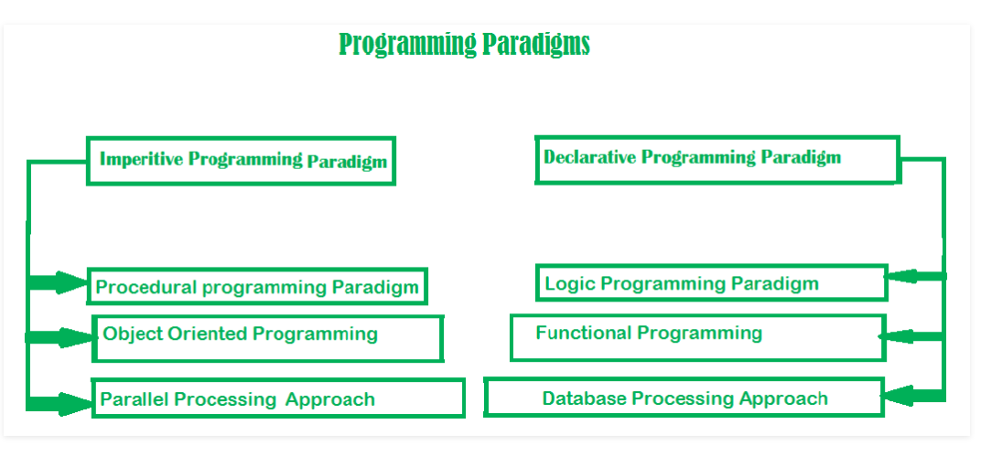

1. **Imperative programming paradigm**

It's one of the most traditional programming paradigms. It has a strong connection to machine architecture. Its architecture is based on Von Neumann's. It operates by using assignment statements to change the state of the application. By altering states, it conducts a step-by-step operation. The primary focus is on achieving the goal. The paradigm is made up of numerous statements, each of which is executed and the outcome is saved.

**Advantage:**

1. Very simple to implement
2. It contains loops, variables etc.

**Disadvantage:**

1. Complex problem cannot be solved
2. Less efficient and less productive
3. Parallel programming is not possible
   1. Procedural programming paradigm
   2. Object-oriented programming paradigm
4. **Event-Driven Programming**
5. **Conclusion**

**Chapter 3 – IDE features(P4 – M2 – M3 – M4)**

1. **Definition**
2. **Features of IDE**
3. **Explain and evaluate the debugging process in the IDE used and how it helped with development**
4. **Evidence**
5. **Developing applications using an IDE versue developing application without using an IDE**

**Chapter 4 – Design and Implementation(P3 – P5)**

1. **Flowchart**
2. **Source code and screenshots**
3. **Coding standards used in the program**
4. **The benefits of using coding standards**